**MFA**

Multi-Factor Authentication:

Multi-factor authentication (MFA) is a multi-step account login process that requires users to enter more information than just a password.

IAM User Created:

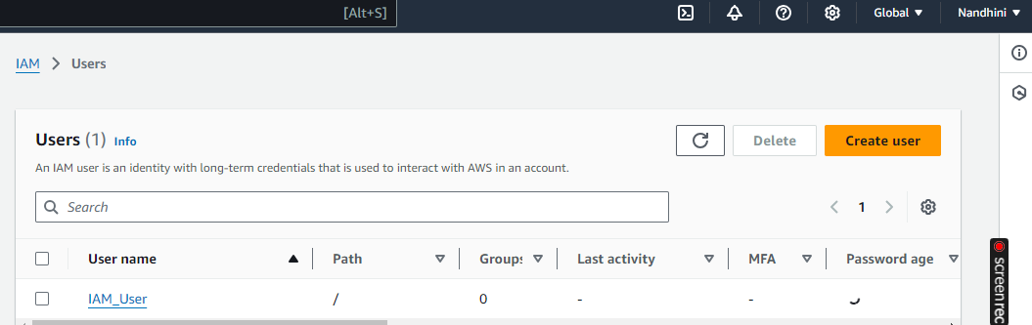

User-created without MFA:

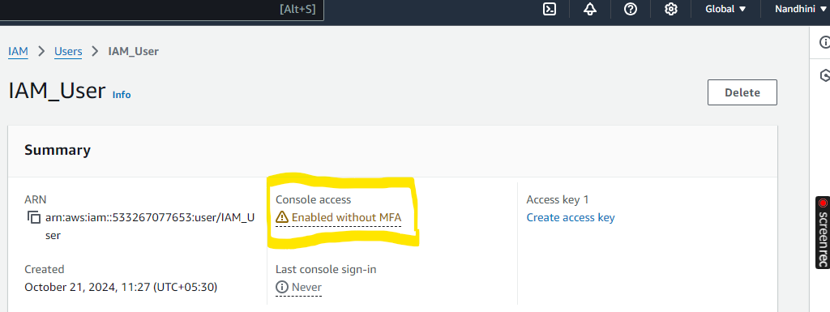

MFA provided:

]

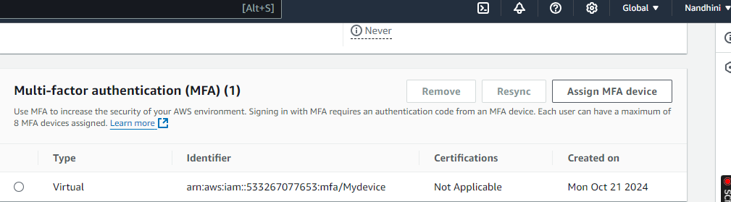

Logged in IAM user account using MFA:

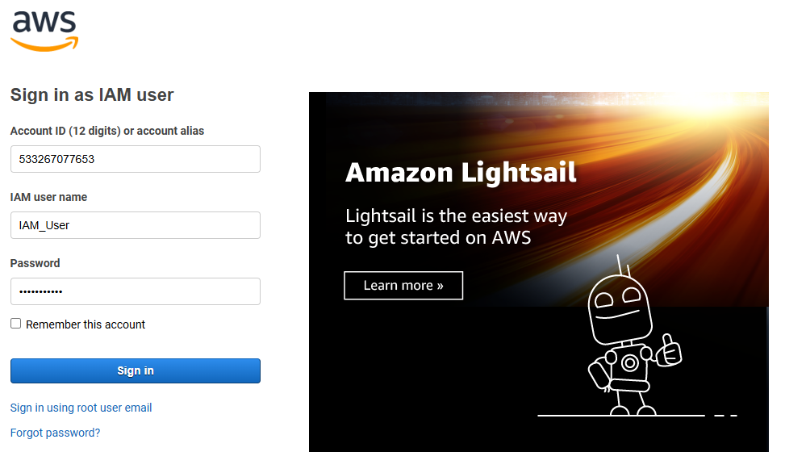

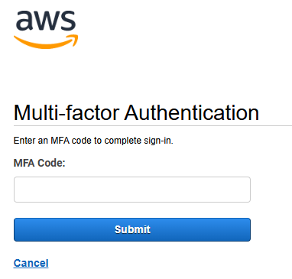

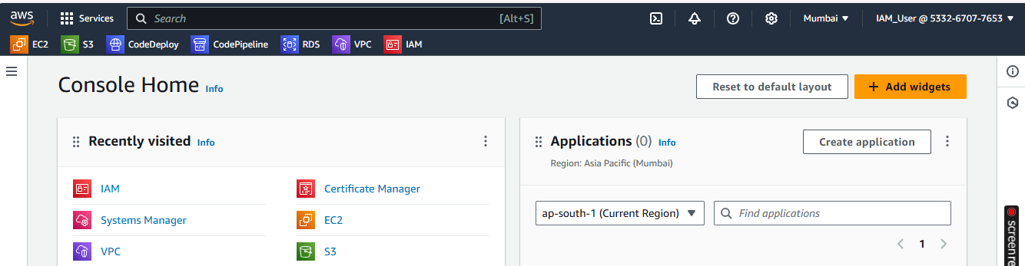

Finally removed MFA Authentication:

